
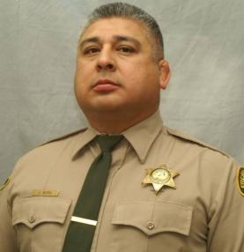

Deputy Sheriff Jose Mora
Fresno County Sheriff’s Department

EOW: September 7, 2020

Age: 44 Year of Service: 16 years Cause: COVID19 Suspect: N/A

On Monday, September 7, 2020, Deputy Sheriff Jose Mora passed away from Covid19. This virus was contracted while Jose and another deputy were transporting a homicide suspect from Oklahoma, back to Fresno. Jose was performing his job when this occurred.

Jose was a 16-year veteran of the Fresno County Sheriff’s Office. Prior to joining the Sheriff’s Office in 2004, Jose was a police officer for the City of Firebaugh for four years.

Jose was one of the guys who was always there and willing to help his partners and the community he served. Jose was a hard worker and diligent at the cases he was assigned. Jose worked a variety of assignments including Court Services, Patrol and Investigations.
Jose is survived by his wife Carol, three adult children and one step son. Jose loved serving people and loved the people he worked with. Jose will be dearly missed by this agency. Rest in peace my friend.

